W4115 PROGRAMMING LANG & TRANSLATOR

EXGOL LANGUAGE TUTORIAL

Team Name: EXGOL

Team members:
Language and tools guru Suhan Canaran -sc3055@columbia.edu
Project manager Andreas Nilsson - apn2107@columbia.edu
System architect Akshat Sikarwar -as3515@columbia.edu
System integrator Eric Schmidt -es2103@columbia.edu
Tester and validator Aaradhi Tilva -at2577@columbia.edu

Table of Contents
1 Introduction 3
2 Language Purpose 4
2.1 Motivation 4
2.2 Language Scope Decisions 4
2.2.1 Grid Structure 4
2.2.2 Simulation Purpose 5
3 Example Programs 6
3.1 Hello EXGOL 6
3.2 Conway’s Game of Life 8
3.3 Competing Species 9
4 Writing Transition Rules 12
5 References 18

1 Introduction
The aim of this tutorial is to give a step by step introduction to using the cellular automaton simulation language EXGOL. Since the scope and domain of the language is fairly limited the aim of the tutorial is to be fairly exhaustive. Even so the main focus lies on quickly giving the reader practical experience in working with EXGOL code. For a complete description of EXGOL including grammar see the language reference manual [2].

The tutorial is divided into three main parts. The first part gives an overview of the purpose and scope of EXGOL. It and can be seen as an extension to the motivation. The second and main part consists of a number of commented example programs of increasing complexity. Included in the second part is also a guide to how to compile and run EXGOL programs. To quickly get started with EXGOL simply jump to section 3.1 directly. The third part is a detailed discussion of how to write meaningful EXGOL transition rules. Since the goal of EXGOL is to simulate cellular

Since EXGOL describes a simulation there is a fair amount of boiler plate required to for a simple “Hello EXGOL” example. Therefore the tutorial is based on a few example programs with every code statement being described in detail.

2 Language Purpose

2.1 Motivation
A cellular automaton is a mathematical model that consists of a grid of cells, where each cell can be in any of set of states, with an initial configuration specifying the initial state of each cell, and a set of rules that are applied to each cell in the grid to determine its state in the next time-step of the automaton. British mathematician John Conway’s “Game of Life” [1] is a cellular automaton with two states, “alive” or “dead,” and three rules:

1. If alive and have fewer than two live neighbors, die (as if by loneliness)
2. If alive and have more than three live neighbors, die (as if by overcrowding)
3. If dead and have exactly three live neighbors, become alive

This is the most famous cellular automaton. We believe cellular automata may be useful tools for modeling a variety of phenomena, as the game of life suggests they are, and so we would like to make it easy to construct and visualize them. Our programming language aspires to make it very easy to describe and visualize a diverse set of automata, especially automata like the game of life, which have English interpretations.

2.2 Language Scope Decisions

2.2.1 Grid Structure
A grid is simply an n-dimensional set of cells set next to each other. A grid is not a generic graph. In the typical 2-dimensional case for instance grid is a rectangle with m rows and n columns where n and m are chosen by the programmer. In the 1-dimensional case it is a line and in the 3-dimensional case a block. A grid can be either bounded or wrapped. In a bounded grid cells cannot grow outside of the grid whereas in w rapped grid cells “wrap around” the grid to grow on the opposite side.

2.2.2 Simulation Purpose
The purpose of EXGOL is to facilitate visual simulations of cellular automatons similar to that of Conway’s game of life. There exist a number of extended Game of Life implementations but our aim is to allow certain extensions in combination with automated parameterization of these extensions. The main extensions which EXGOL provides are:

- Simulations in n dimensions. Simulations in 1-D and 2-D and possibly 3-D will be represented visually while higher dimensions will generate text output.

- An arbitrary number of states for each cell.

- Cell state transitions being determined by a randomly big neighborhood around that cell. That is not only the closest neighbors, but also neighbors further away can affect the state transition of the cell.

- Several concurrent, possibly competing cell classes. In Conway’s Game of Life only one cell type is being used. We have extended the cell concept to include a cell class as well, see the Competing Species example in section 3.3.

- Introduction of probabilities to the state transitions, see the Competing Species example in section 3.3.

3 Example Programs

3.1 Hello EXGOL
As our ﬁrst program, let us display “EXGOL” on the grid.

Code Listing 1 - Hello.exgol
class := {cell:black}
state := {alive}
gridsize := {10, 50}
gridtype := bounded
%%
# Transitions types
trans off := alive -> empty
trans on := empty -> alive

# Transition rules
transrule on {
trans := on
}

transrule off {
trans := off
}

%%
# Fill the cells with EXGOL
populate(black, line(x1, y1, x2, y2))
populate(black, line(x1, y1, x2, y2))
.
populate(black, circle(x, y, r)) # O in EXGOL

# Set of transitions to be run in a simulation
sim HELLO = {on, off}

# Begin the simulation
start(0, HELLO) # 0: no limit on generations

Save this program in a text ﬁle with a .exgol extension, for example, hello.exgol. You can then execute this program by invoking the EXGOL interpreter with the following command:

$ ./exgol hello.exgol

If everything went right you would see a window with 10 x 50 grid and the word EXGOL displayed in black. Let us brieﬂy look at the structure and syntax of this program. The #character denotes the beginning of a comment. The comment is terminated at the end of line. Every EXGOL program has three sections. These three sections are separated by the %% characters as shown above. The tree sections are initialization, transition deﬁnition and the program execution. Let us study what happens in the initialization section. This section would be fairly uniform across all programs. It informs the interpreter about the diﬀerent classes of cells that exist and the diﬀerent states that cells of each class can be in. Probably, the simplest construct to visualize is the grid. In the program above, the statement: grid := {10, 50} instructs the interpreter that we would like to run the simulation in a grid which is 10 cells deep and 50 cells wide. The grid type is speciﬁed by gridtype and can be either bounded or wrapped.

The transition deﬁnition section is the core of an EXGOL program. It assigns names to diﬀerent transitions (using the transrule keyword), and then speciﬁes, the diﬀerent conditions under which a transitions can take place. It also determines the probability, if any, associated with the transition. The condition statement determines under which condition, a given transition takes place. Our rules simply say, that if a cell is empty, it should transition to the alive state and vice versa. Since we have only one class of cell in this example, we do not need to specify the class that would occupy a given cell. Note that the trans_t and trans can have the same identiﬁers. It will always be clear which one is being used by the context of the usage. One could deﬁne any number of transitions in a given EXGOL program. However, we may want to run a simulation with a subset of the transitions.

To achieve this there is the sim construct. Here, we have chosen to use all the transitions. One could make diﬀerent sets of transitions and run them by calling multiple start functions. The start function runs the simulation in a new window as shown. Another aspect that we need to take care of, is the initialization of the grid. That is, that state of the grid when the simulation begins. In this example we would like to populate the cells in such a way, such that it spells out EXGOL. We have achieved this using the populate function. The populate function ﬁll cells, with a given class. Diﬀerent distributions can be speciﬁed for populating the grid, such as a random variable, or as geometric shape. We have used lines and circle to display EXGOL

3.2 Conway’s Game of Life
The following EXGOL program will simulate the classical Game of Life:

Code Listing 2 - Conway.exgol
class := {cell}
state := {alive}
gridsize := {10,10}
gridtype := bounded
%%
trans BREED := empty -> alive
trans DIE := alive -> empty

transrule BIRTH {
trans := BREED
condition := peer[1] = 3
}

transrule LONELY {
trans := DIE
condition := peer[1] < 2
}

transrule OVERPOPULATION{
type := DIE
condition := peer[1] > 3
}
%%
populate(cell, poisson(0.1))
sim CONWAY := {BIRTH, LONELY, OVERPOPULATION}
start(100, CONWAY)

Let us see how this program simulates Conway's Game of Life. The rules of the game [2] and how they are met in the program is explained in the following:

Any live cell with fewer than two live neighbours dies, as if by needs caused by underpopulation. This rule is defined by the LONELY transition. Any live cell with more than three live neighbours dies, as if by overcrowding. This rule is defined by the OVERPOPULATION transition. Any live cell with two or three live neighbours lives, unchanged, to the next generation. Since there is no transition in this rule, that is, the cell remains unchanged, we don't require any transitions in the program. Any dead cell with exactly three live neighbours becomes a live cell. The BIRTH transition implements this rule.

An explanation of how cells are referred is required at this time. The cell under consideration is the todo kernel. All other cells are identified with reference to the kernel cell. The keyword neighbour refers to all non-empty cells, around the kernel, irrespective of their class. The keyword enemy are non-empty cells which are not of the same class as the kernel. peer are cells which are of the same type as the kernel. For cells at a given distance the count of neighbour = peer + enemy.

The condition in BIRTH says that if the count of peer is equal to 3 then apply the BIRTH transition. It also specifies, that peer at a distance of one hop are considered in the count.

We can specify a range of cells to be considered in a condition statement. For example, peer[2-4] would count peers at a distance of 2, 3 or 4 from the cell in question. An equivalent representation of the same is to enumerate the proximity like so: peer[2, 3, 4]. We could have also said peer[1, 3] and this would have considered cells at a distance of 1 and 3, but not 2. The logic behind LONELY and OVERPOPULATION is similar.

3.3 Competing Species
The following EXGOL program employs more advanced features of EXGOL to represent two competing species.

Code Listing 3 – CompetingSpecies.exgol
class := {bacteria:black, virus:blue}
state := {healthy, sick}
gridsize := {20,20}
gridtype := wrapped
%%
trans BREED := empty -> healthy
trans DISEASE := healthy -> sick
trans DIE := {healthy, sick} -> empty

# A bacteria/virus is born whenever there are more than 2 peers
# within the proximity of 2
transrule BIRTH{
type := BREED
condition := peer [1-2] > 2
resolve := {bacteria, virus}
}

# Bacteria dies of loneliness if the number of peers in proximity 1 is less than 3
transrule LONELYBact{
type := DIE
class := {bacteria}
condition := peer[1] <= 2
}

# Virus dies of loneliness if the number of peers in proximity 1 is less than 4
transrule LONELYVir{
type := DIE
class := {virus}
condition := virus[1] <= 3
}

# A bacteria/virus gets sick if the total number of sick neighbors is higher than # the total number of healthy neighbors
transrule SICK{
type := DISEASE
condition := neighbor.healthy[1] <= neighbor.sick[1]
prob := 0.9
}

# A bacteria/virus gets sick randomly
transrule SICKRANDOM{
type := DISEASE
prob := 0.05
}

# A bacteria/virus gets killed if the number of healthy enemies is higher
# than then number of healthy peers
transrule KILLED{
type := DIE
condition := enemy.healthy[1] > peer.healthy[1]
prob := 0.7
}

%%

# populate the grid. Populate always uses state 0
populate(bacteria, normal(0.1))
populate(virus, normal(0.2))

# Declare two simulation types
sim LONELYWAR := {BIRTH, LONELYBact, LONELYVir, SICK, KILLED}
sim WAR := {BIRTH, SICK, KILLED}

start(10, WAR)
start(100, WAR)
start(100, LONELYWAR)

This program defines two classes of cells: bacteria and virus. When a cell is occupied by one of these classes, it can be either healthy or sick as specified by the state statement. If a cell is not occupied, it is empty.

The grid is declared to be wrapped. The best way to explain a wrapped grid is to visualize it with an example. Suppose the kernel is the cell at location (0, 0); then peer[1] would be the following set of neighbors, enumerated clock wise, from the top-left cell {(19, 19), (19, 0), (19, 1), (0, 1), (1, 1), (1, 0), (1, 19), (0, 19)}.

Three transitions are defined in this program. Note that the transition DIE occurs when a cell transitions to the empty state from either the healthy or sick states. In general, everywhere a list of items is required in EXGOL, it is enclosed in a set of curly braces {}.

Let us look at the BIRTH transition rule. It introduces the resolve statement, which is basically a list of classes. This statement determines the class of cell to which the state transformation occurs. That is, it determines the class of cell that would occupy the kernel once the transition is applied. In a simulation with two or more classes it gives the order of precedence if more than one class satisfies the condition statement.

The class statement within the transition rule matches class of the kernel and determines whether to consider the kernel for transition or not. It is different from the class statement in the initialization section, however, it shares the same semantics and is also a list of classes, enclosed by {}.

The last remaining rule, that we need to cover is prob. It is a floating point number and can take values between 0 and 1, both inclusive. Example values are .1, .75, .99, 1, etc. It determines the probability with with a given transition occurs, provided the 'condition' has been satisfied. In the example above, the SICK transition rule specifies that the DISEASE transition would take place 9 out of ever 10 times the condition constraint is met.

That brings us to the simulation section. In the example above, this section begins with the sim statement. This statement is simply a list of transition rules. It enables us to select a subset of the transition rules in a given program. We can then run a simulation for x generations (iterations) by invoking the start procedure like so:

start (x, sim_name)

If x is 0, it instructs the simulator to run the simulation indefinitely. It can take any integral value up to 2³²-1.

The last construct that we need to learn is the populate procedure. This procedure enables the programmer to describe the initial configuration of the grid.

4 Writing Transition Rules

The key component of EXGOL. Every cell is compared to a transition rule, and upon matching the criteria, is transformed into a new state defined in the transition type. Let's first start by showing you how to read a transition rule in exgol.

trans DISEASE := healthy -> sick
transrule SICK{
type := DISEASE
condition := neighbor.healthy[1] <= neighbor.sick[3]
prob := 0.9
}

Transition rule SICK performs the DISEASE transformation with a 90% probability when the kernel's count of healthy neighbors within one unit is less than or equal to the count of sick within three units.

You have just taken the first step as an expert exgol programmer. Now lets look at interpreting this rule one step at a time. First thing you recognize is that the transformation rule has a name SICK. This rule has three sections to it: type, condition and a probability.

During simulation, the EXGOL engine will visit every cell and filter it through the transition rules to decide on the next state of the visited cell. The cell that is being visited is called the kernel. If kernel matches the criteria, then the transformation will be performed. The transformation that will be performed is defined by the type deceleration in the rule body. The type declaration for our example is called DISEASE. The DIEASE transformation is defined as going from state healthy to state sick..

Once the EXGOL engine knows that this rule applies to cells in healthy state, it first verifies that the kernel is in the healthy state. Once this is satisfied, we know that there is a possibility that this transformation will occur, once the remaining conditions are matched.

Lets look at the anatomy of a condition.

condition := neighbor.healthy[1] <= neighbor.sick[3]

neighbor - This keyword tells the engine to look for all the classes that is within the proximity of the kernel regardless of class differences.

healthy - this tell the exgol engine to count cells that are in state healthy. Now, neighbor.healthy : this translates into, all the cells in the proximity of the kernel that are part of class neighbor (remember this keyword translates into all classes except for null class) and are in state healthy (this has to be a state that was defined in the init section) And finally, the range operator tells the engine to limit its search to only 1 cell around the kernel. In this case, it is the immediate cells of the kernel.

Now that we know how to translate left hand side on the condition, we see the comparison operator <= followed by the right hand side... Can you translate it?*

And the final statement in our example prob as you may have already guessed, tells the compiler to perform the transformation with a probability of 90%, meaning that regardless of other conditions, this transformation will statistically occur only 90% of the time.

Before we are done with this tutorial, lets look at two more definitions that can exist in a rule.

class:={virus}

This statement in the body of a rule tells the engine to also verify that the kernelbelongs to this class. In other words, if this line was in our example, the transformation would apply to Cells which are in the correct state and belong to virus class. This allows us to make class specific rule sets. And finally

resolve := {bacteria, virus}

The resolve statement is used for conflict conditions when two or more classes are competing to populate an empty cell. Using this statement, you can define precedence order of the winning classes for populating a cell.

Now we know how to read and write a transformation rule. Can you decide the outcome of the following example using this rule?

class:={Blue:blue, Red:red, Yellow:yellow}
state:={live, sick}
alias happy := {red}
%%
trans DISEASE := live -> sick
transrule SICK{
type := DISEASE
class := {Red}
condition := happy.live[1-2] < enemy.sick[3]
prob := 0.75
}

Hint:
There are total of Yellow 3 sick and 6 live
Blue 2 sick and 3 live
Red 6 live cells
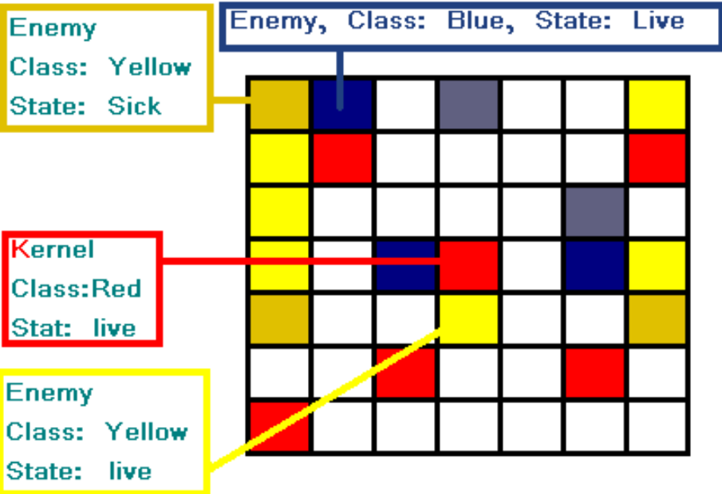
Watch for the proximity.

Lets read our rule first.
“Transition rule SICK performs the DISEASE transformation with a 75% probability when the kernel belongs to class red, and count of cells in live state belonging to a class defined in alias reds from 1 to 2 units is less than the count of sick cells of any class that does not belong to the kernel's class at third unit ring” have I confused you enough already?

The kernel is a live red cell (type and class statements are satisfied)
Lets look at the condition:
happy.live[1-2]
Happy, as defined, is an alias for a class list and the only element is red. So we are looking for kernel's neighbors that belong to class red, and are in state live and are within 1 to 2 units near the kernel. I can count 3....
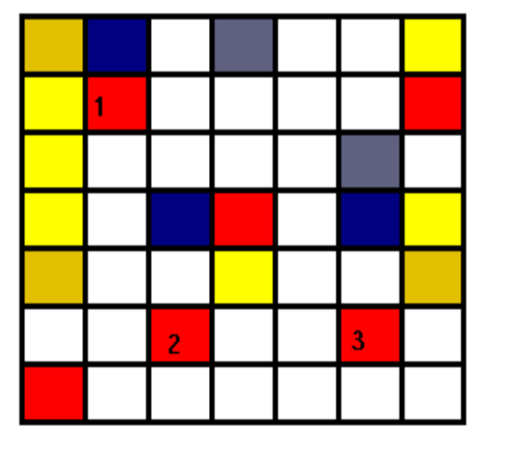
Lets look at the right hand side of the condition:
enemy.sick[3]

Enemy says, we are interested in classes that is not the same as the kernel or null class(Yellow and blue!). And that the state sick, only in the 3rd ring from the kernel.

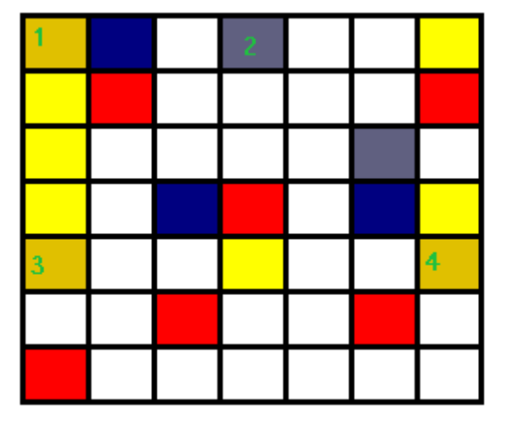
I can count 4!

Now lets run the comparision, 3<4
YES!
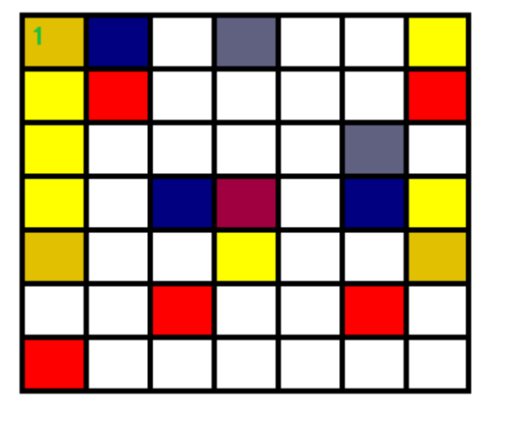
So with a probability of 75%, the final result of this transformation would be one poor little sick red cell :(

5 References
[1] http://en.wikipedia.org/wiki/Conway%27s_Game_of_Life
[2] EXGOL Language Reference Manual
[3] http://jflex.de/ - JFlex download and documentation
[4] http://byaccj.sourceforge.net/ - BYACC/J download and documentation

